CONTACT MANAGER
PROJECT DOCUMENTATION
INTRODCUTION
Project Title: “ Contact Manager”
Team Members:
- VIVEKA .S
- SIVASHREE .S
- SOWNDARIYA .V
- SHEFFANA BEGAM .Y
API IMPLEMENTATION SCREENSHOTS
The following screenshots demonstrate the successful execution of Contact Manager APIs using Thunder Client in Visual Studio Code, showing the request body and corresponding server responses.
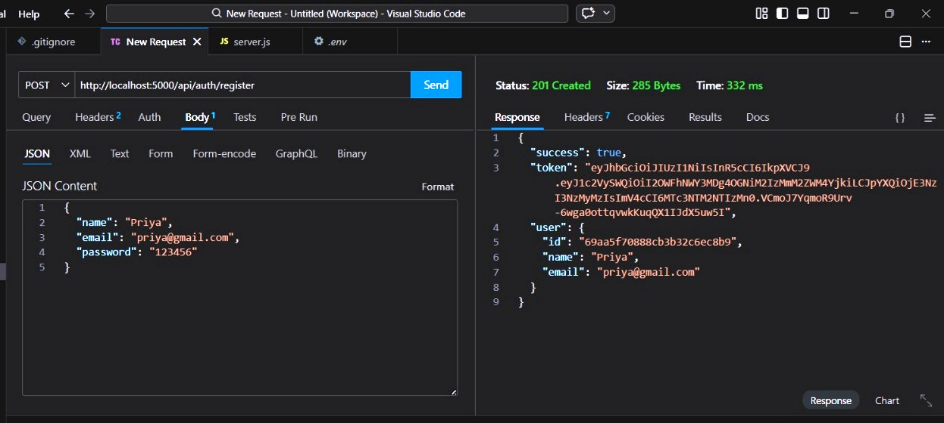
- REGISTER API
- This API allows a new user to create an account in the Contact Manager system.
- The user provides name, email, and password in the request body.
- After successful registration, the system returns a JWT authentication token and user details.
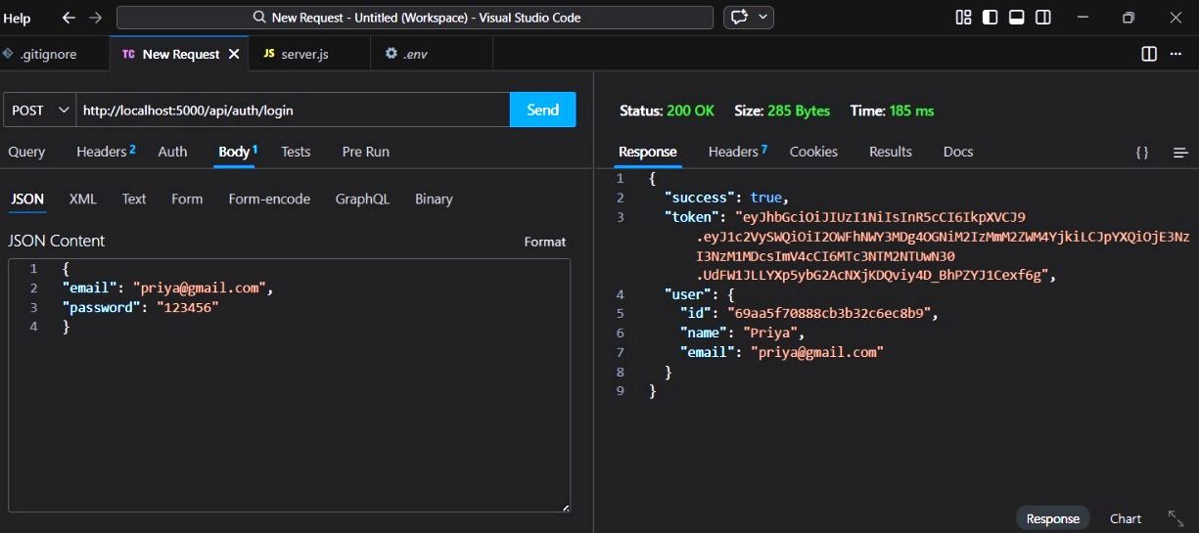
- LOGIN API
- This API allows an existing user to log in to the Contact Manager system.
- The user provides email and password in the request body.
- If the credentials are valid, the system returns a JWT authentication token and user details, which will be used for accessing protected APIs.

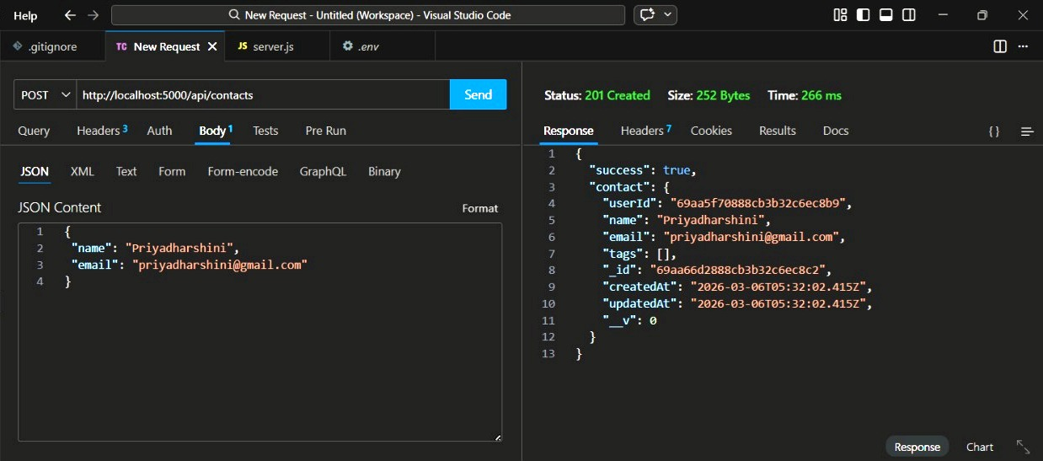
CREATE NEW CONTACT

- This API allows the authenticated user to add a new contact to the system.
- The request body includes details such as name and email of the contact.
- After successful creation, the contact information is stored in the MongoDB database and returned in the response.

- UPDATE CONTACT
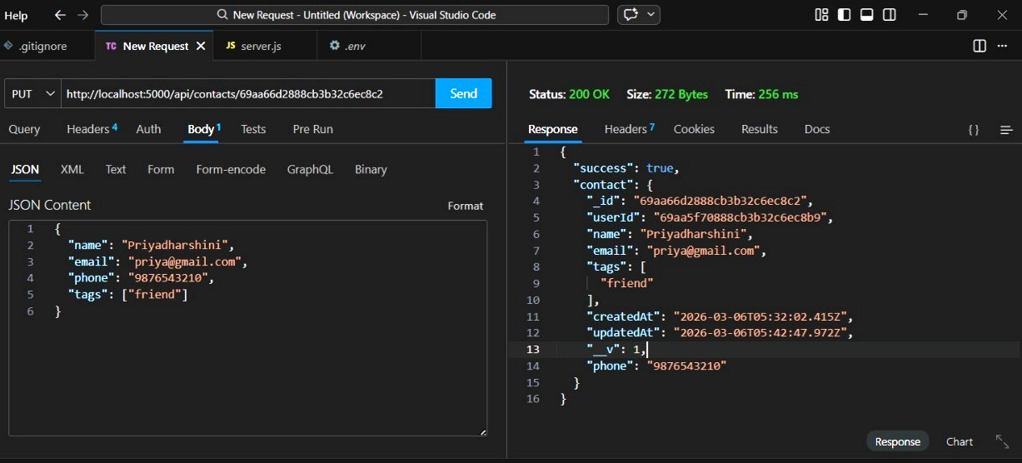

- This API allows the user to update the details of an existing contact.
- The contact is identified using its unique contact ID in the URL.
- The updated details such as phone number and tags are saved successfully in the database.
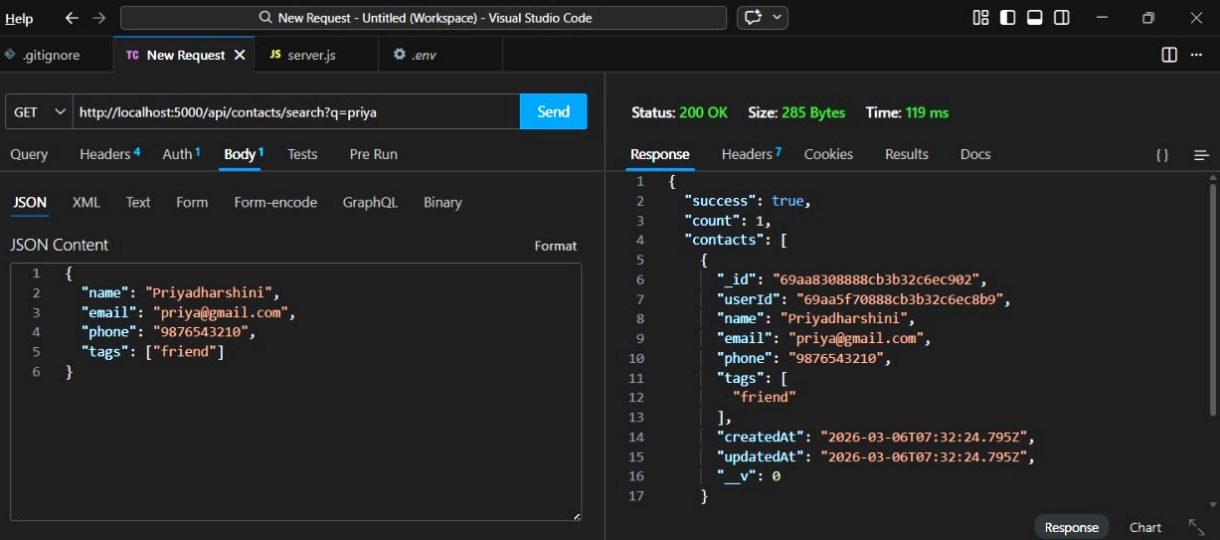
- SEARCH CONTACT

- This API helps users search for contacts using a query parameter.
- The search keyword is passed through the URL (for example: ?q=priya).
- The system returns a list of contacts that match the search keyword.

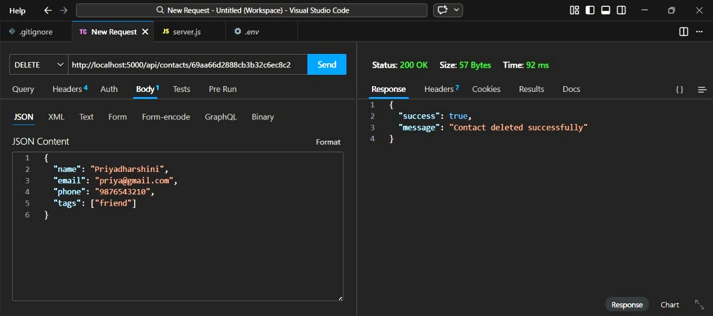
- DELETE CONTACT

- This API allows the user to delete a specific contact from the Contact Manager system.
- The contact is identified using its unique contact ID.
- Once deleted, the system returns a confirmation message that the contact was removed successfully.

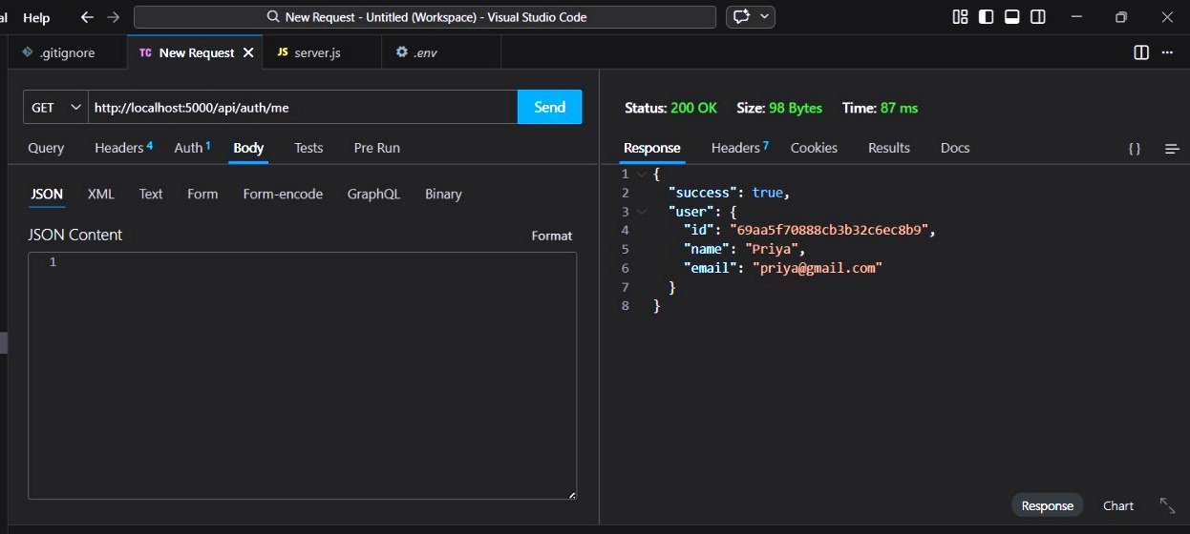
- GET CURRENT USER
- This API retrieves the details of the currently authenticated user.
- The request uses the JWT token in the authorization header to verify the user.
- The response returns user ID, name, and email information.

